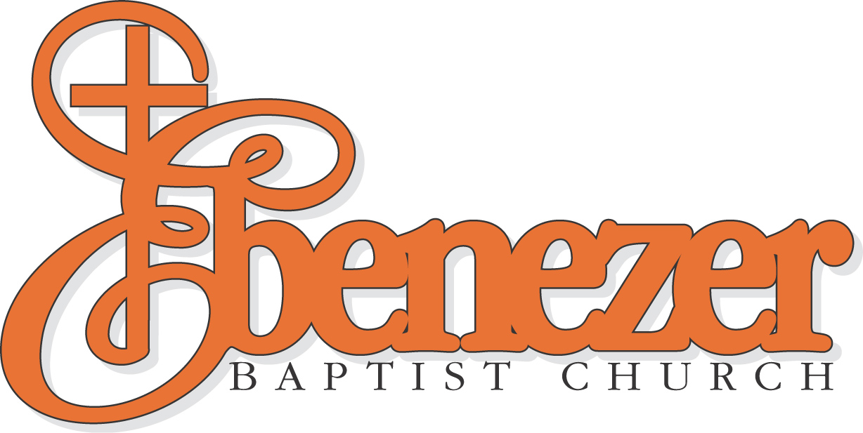

The Reverend Raphael G. Warnock, Ph.D.
Senior Pastor
Accountant
Job Description

The accountant’s primary responsibilities are split approximately 70% toward accounting tasks, projects, credit card processing, and financial reporting support; 10% toward Accounts Payable oversight, and 20% toward accounting software and application management for the Finance Team. This position is an exempt full-time salary position in the Finance Department and reports to the CFO.

Essential Functions

- Oversees processing of payables and entry of invoices as required.
- Oversees processing of reimbursement requests as required.
- Reviews and questions payables and invoices as needed.
- Oversees weekly A/P payments, check processing, & BILL payments when required.
- Assists with processing approved online payables and processes payments.
- Generates manual checks and assures proper coding and approval.
- Assists with processing payroll entry as required.
- Assists with monthly bank reconciliations.
- Assists with preparing G/L entries for the accrual of payables, payroll, and other assets & liabilities.
- Assists with staff inquiries regarding budgets, payments, credit card issues, and other requests.
- Assists with the allocation of expenses to each location per Ministry direction.
- Assists in monthly closing and report generation.
- Questions payment terms, discounts or sales tax exemptions as needed.
- Assists with onsite and offsite secure document storage.
- Assists with updating equipment & asset spreadsheets & supports auditor requests during annual audit.
- Prepares miscellaneous reports such as actual budget variance analysis and provides them to ministry leaders as requested.
- Supports miscellaneous finance projects, creates, and maintains spreadsheets and graphs as needed.
- Supports annual budget preparation including helping to train employees on software budget tool, discussing individual budgets.
- Works closely with CFO as required.
- Maintains all vehicle records including title and registration.
- Assists the CFO with monitoring cash flow.
- Assist & oversee the annual creation of 1099s.

Supervisory Responsibilities:
- This position does not directly supervise an employee. However, this position does work closely with the finance Assistant to ensure expense items are accounted for correctly and accurately.
MINIMUM QUALIFICATIONS:
Bachelor’s degree in accounting plus two or more years of related experience; or equivalent combination of education and experience. Related experience includes accounts payable, bookkeeping, or general accounting experience.

Competencies and Experience
- Professional experience working with confidential and sensitive information.
- Ability to prioritize daily tasks and meet timely obligations with many clients.
- Knowledge of accounting processes and advanced mathematical skills
- Skilled using various accounting software and experience in troubleshooting common accounting program problems.
- Experience with excel and PowerPoint presentation.
- Experience with grant and church type data-based systems.
- High levels of persistence, curiosity, and enthusiasm
- Excellent presentation, verbal, written and interpersonal skills.
- Has resiliency/persistency, high energy, and a commitment to achieving goals.
- Ability to communicate and collaborate effectively with all levels of staff, members and committees.
- Must be forward-thinking and have high ethical standards and an appropriate professional image.
- knowledge of GAAP accounting, compliance, and reporting

Appy: Careers@ebenezeratl.org

101 Jackson Street, N.E. • Atlanta, Georgia 30312 • Office (404) 688-7300 • info@ebenezeratl.org • www.ebenezeratl.org

